Wendy Maruyama’s ‘Executive Order 9066: The Tag Project’ Comes to San Jose

‘Toriawase’ also on view at Institute of Contemporary Art.

Fri, Mar 14 2014
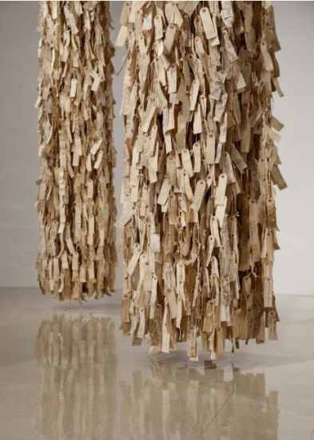
“Wendy Maruyama: Executive Order 9066: The Tag Project,” partial installation view (San Diego State University), 2012, paper, string and ink, each approximately 11’x2’ in diameter. (Photo by Kevin J. Miyazaki)
SAN JOSE — The San Jose Institute of Contemporary Art (ICA), in collaboration with ArtObjectGallery and the Japanese American Museum of San Jose (JAMsj), presents “Wendy Maruyama: Executive Order 9066: The Tag Project” through May 24.
This multi-venue exhibition explores the complex story of the Japanese American internment. This is the fifth presentation of this exhibition, which premiered in May 2012 at San Diego State University. The Society of Arts and Crafts in Boston presented the exhibition in the fall of 2012 and has organized the show’s traveling schedule to Arizona and Northern California.

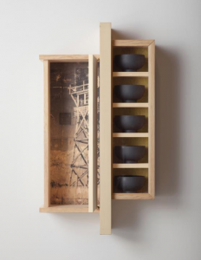
Also on view through May 17 at ICA is “Toriawase,” a group exhibition that juxtaposes traditional and historical Japanese art and objects with selected contemporary Western artwork.
In 1942, President Franklin Delano Roosevelt signed Executive Order 9066, authorizing the internment of tens of thousands of American citizens and resident aliens of Japanese ancestry. Wendy Maruyama, a third-generation Japanese American and highly regarded educator and artist/furniture maker based in San Diego, has created a compelling body of work examining this period in American history. The exhibition includes three integrated parts: “Executive Order 9066,” “The Tag Project,” and an exhibition of historical artifacts.
“The Tag Project” is presented at the ICA, 560 S. First St. (Downtown). Each interned citizen wore a paper identification tag, which inspired Maruyama to embark on the project. Enlisting help from hundreds of volunteers across the country, she recreated each tag – 120,000 – to represent every person who was sent to one of 10 internment camps. This large-scale installation consists of 10 groupings of 120,000 recreated paper identification tags suspended from the ceiling that evoke a powerful sense of the humiliation endured by the internees.
Wendy Maruyama, “Watchtower,” 2008, pine, sitka spruce, fir, ink and painted wood bowls, 32x18x8 inches, courtesy of Jane and Stephen Lorch. (Photo by Kevin J. Miyazaki)

“Executive Order 9066” is presented at ArtObjectGallery, 592 N. 5th St. (Japantown). This exhibition features a series of wall-mounted cabinets and sculptures created by Maruyama that enshrine elements of life in the internment camps. The pieces integrate photo transfers based on the documentary photographs of Dorothea Lange and Toyo Miyatake in conjunction with materials such as barbed wire, tar paper and domestic objects.
“Executive Order 9066: Memories and Artifacts” is presented at the Japanese American Museum of San Jose, 535 N. 5th St. (Japantown). This exhibition highlights artifacts from the museum’s permanent collection that reveal the historical events surrounding the forced incarceration of Japanese Americans.
“‘Executive Order 9066’ not only reminds us of a dark time in our nation’s history but also provides context for the current conversation regarding immigration reform, racial profiling and privacy laws,” says Cathy Kimball, ICA executive director. “We’re honored to partner with JAMsj to lend historical perspective to their contemporary presentation as well as ArtObjectGallery to showcase sculptures that incorporate artifacts from the camps.”
Opening reception events will be held on Friday, March 14, at each of the following exhibition venues: “Wendy Maruyama: Executive Order 9066: The Tag Project” from 6 to 8 p.m. at San Jose ICA; “Wendy Maruyama: Executive Order 9066” from 7 to 9 p.m. at ArtObjectGallery; “Executive Order 9066: Memories and Artifacts” from 6 to 9 p.m. at JAMsj. A free shuttle bus will transport guests between opening reception events.
An accompanying catalog with an essay by Dr. Lowery Stokes Sims, curator at the Museum of Arts and Design in New York City, will be available for purchase at presenting venues.
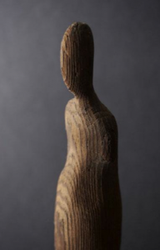
A conversation and book-signing with Maruyama will take place on Thursday, March 20, at the ICA. Networking and socializing from 6:30 to 7 p.m.; “Talking Art” session from 7 to 9 p.m. No-host bar and light snacks will be available. $5 for members, $10 for non-members. Pay at the door.
“Toriawase” loosely means to select and combine elements of beauty and to enjoy the harmony that results from their coming together. This concept, which is central to the Japanese tea ceremony, informs the approach to this group exhibition. This presentation juxtaposes traditional and historical Japanese art and objects including ancient scrolls, lacquer works and tea ceremony utensils with selected Western artwork from contemporary artists including Jaap Bongers, Tim Craighead, Jay DeFeo, Marc D’Estout, Bean Finneran, and Joel Shapiro.
Western artists whose works are on view in “Toriawase” have not been directly influenced or inspired by a Japanese aesthetic. Rather, they share a similar aesthetic across time and across continents.
Anonymous, Buddha, c. 14th century, wood, 12×1¼x1½ inches, courtesy Mitsui Fine Arts.

This exhibition is co-curated by the ICA and Misako Mitsui, an internationally recognized curator and educator of Japanese art.
The San Jose ICA (www.sjica.org) is an energetic art space dedicated to making contemporary art accessible and exciting to audiences of all ages and backgrounds. Exhibitions are presented in three galleries that display the most current, relevant and often challenging art from the region, the nation and the world. The ICA is activated by opening receptions, monthly gallery walks, programming in the front windows, panel discussions, printmaking workshops, brown bag lunches and impromptu conversations in the galleries.
The Japanese American Museum of San Jose (www.jamsj.org) is an all-volunteer 501(C)(3) organization whose mission is to collect, preserve and share Japanese American history, culture, and art with a focus on the greater Bay Area. Located in one of three remaining Japantowns in the U.S., JAMsj documents the early history of San Jose’s Japantown, and the wartime incarceration, including the contributions of the 442nd Regimental Combat Team/Military Intelligence Service. The museum also has an authentic replica of a camp barracks furnished with artifacts from internees. JAMsj owns the largest collection of pre-war farm equipment used by Japanese and Japanese Americans who were major contributors to Santa Clara Valley’s agricultural industry. JAMsj hosts regular public programs and provides speakers, as well as guided tours of San Jose’s historic Japantown.
ArtObjectGallery (www.artobjectgallery.com) was founded in 2002 by artist Ken Matsumoto and exhibits art from some of the Bay Area’s finest painters, sculptors, and printmakers. As one of only a few private galleries in the Silicon Valley, ArtObjectGallery plays an important role in the arts community by providing an exhibition space for local artists, and it has earned a reputation as a premier gathering space for collectors and the culture-consuming public.

