Day Trippin’: Summer Art Destinations Around the Bay Area
By Christian L. Frock
May 20, 2015

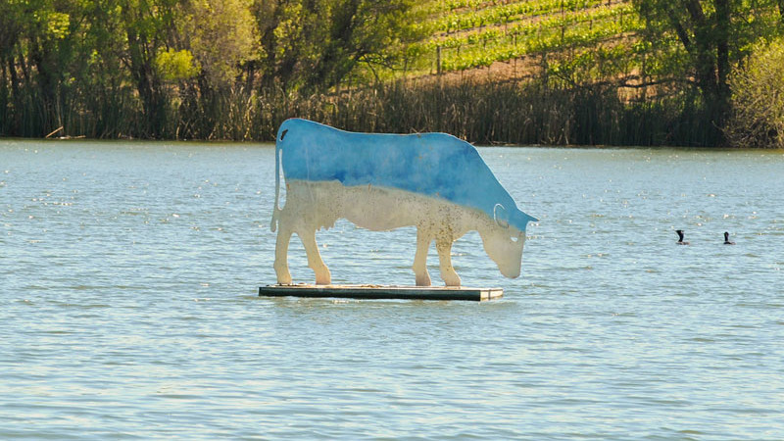
An example of art installation at di Rosa (Courtesy of di Rosa)

“The coldest winter I ever spent was a summer in San Francisco,” Mark Twain once said, according to urban legend. Whether or not he said it hardly matters, so let’s not dwell on it — we all know the city can be miserable in the summer, so the timing is perfect for day trips elsewhere around the Bay Area to get your art fix and expand your horizons.

Each of these five spots promise a whole host of great things to see and do – and yes, eat (if you are from the Bay Area, I know where your priorities lie, don’t worry) – so plan to make it a sunny day of exploration. But before we start, a word to the wise if you actually live in the city: You’ll be heading to the best weather the region has to offer, so feel free to leave your fleece at home and prepare to have fun.

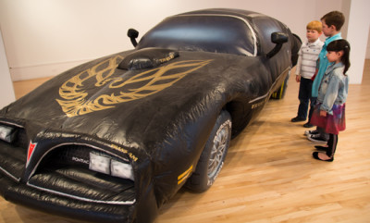
Blow Up
Through June 21
Bedford Gallery

1601 Civic Drive, Walnut Creek
Putting this one right up front as it closes at the end of June – so make it a priority because I think this might end up being one of the best
shows of the summer. Plus kids will love it, making it a great choice for families. This summer’s group exhibition, Blow Up, organized by longtime Bedford curator Carrie Lederer, features large-scale inflatable sculptures by a wild range of artists. From Warhol’s silver balloons to Momoyo Torimitsu’s giant carnival bunnies to Guy Overfelt’s blow up hot rod, there is something for every kid ages 1 – 111 to marvel at in wonder. Just three blocks from BART, so take the train and keep it simple.
“Untitled” by Guy Overfelt, 1999. (Courtesy of Bedford Gallery)

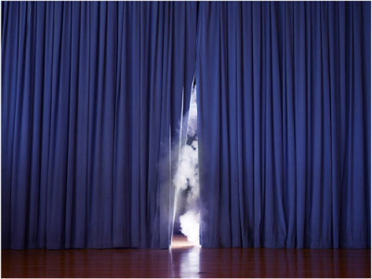
Tongue-in-Cheek
Through July 19
di rosa
5200 Sonoma Hwy, Napa

Nestled amidst rolling green hills, grapevines and a picturesque lake, di Rosa is an extraordinary Northern California art destination. Founded by the late collectors extraordinaire Rene and Veronica di Rosa, di Rosa is widely considered the most significant collection of Bay Area artists in the world, featuring works by Robert Arneson, Enrique Chagoya, Raymond Saunders, Allan Rath and Mildred Howard, among some 800 artists. The Gatehouse Gallery features rotating exhibitions, including this summer’s group show, Tongue-in-Cheek, which focuses on disarmingly funny — and dare I say quirky? — Bay Area artists including Tammy Rae Carland, Jonn Herschend and Kate Rhoades, among others. Explore Napa for the day and see the work of great Bay Area artists? Win, win.
“Smoke Screen” by Tammy Rae Carland, 2013. (Courtesy of of the artist and Jessica Silverman Gallery)

Amy M. Ho: Red Rooms
Through Sept. 12
San Jose Institute of Contemporary Art
560 South First Street, San Jose

“Red Rooms” by Amy M. Ho, 2014. (Courtesy of the Artist and Chandra Cerrito Contemporary)

Okay, the cat’s outta the bag: San Jose has the best weather in the Bay Area. Plus it has the ICA, which presents some of the best exhibitions and programs around. (Yes, I went there.) This summer, the ICA presents an immersive light and video installation by the amazing Amy M. Ho, one of my personal favorites, alongside exhibitions of work by the excellent Rebecca Haseltine, Cassandra Staubing, Naomie Kremer, and Sophia Allison and Leanne Lee. If I was you, I would dovetail my visit with a trip to the Winchester Mystery House – because, mystery – and hit up Falafel Drive In on Stevens Creek along the way for a falafel and a banana milkshake, just sayin’.

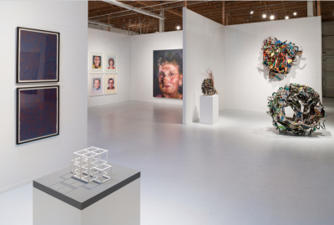
Group Exhibition (By Appointment Only)
Through August 22
Pace Gallery
300 El Camino Real, Menlo Park

Last summer New York powerhouse gallery PACE “Manhattanized” the Peninsula with a cool West coast outpost in a former Tesla dealership on El Camino Real. This unusual pop-up was only supposed to last just through the end of last year, but the gallery has quietly stayed on. Presently it offers a spectacular group show featuring works by Chuck Close and other international art stars. The gallery and exhibition is available to view by appointment only, so remember to call ahead before you go.
Pace Gallery’s current exhibit (Courtesy of Pace Gallery)

Art on the Grounds
Permanent installations – ongoing
Montalvo Arts Center
15400 Montalvo Road, Saratoga

Tucked away in a quiet residential area filled with jaw-dropping historic homes and estates, the Montalvo Arts Center is an oasis away from the Bay Area’s noisy hustle and traffic. In addition to an annual series of three rotating-group exhibitions featuring the work of artists-in-residence, the grounds at Montalvo also host temporary outdoor installations, as well as a number of permanent installations throughout its 175-acre property. This summer sees the temporary installation of five bronze sculptures by Stephen De Staebler, as well as the permanent installation of A Healing Walk by the late Susan O’Malley. O’Malley’s walk, true to the nature of healing, is no simple task and leads visitors straight up hill. Those who endure are rewarded with some of the most extraordinary vistas the Bay Area has to offer, so don’t miss it.

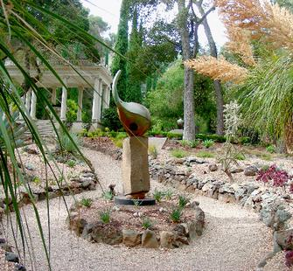
“Broken Wing” by David Middlebrook, 2004.
(Photo by Donna Guldimann)

