Jim Campbell @ SJICA
Posted on 24 January 2016.

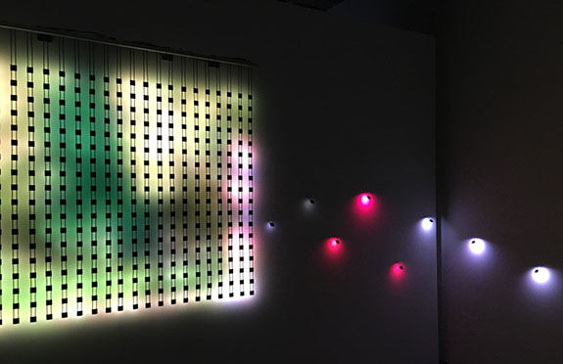
Home Movies Pause, 2014, video installation, custom electronics and 432 LEDs, 66 x 76 x 3"

How can images viewed at a distance assume greater clarity than they do when seen up-close? Or, more tantalizingly: How can anonymous home movies evoke or create memories of our own? These are but a few of the mysteries plumbed by Jim Campbell’s light sculptures. They consist of LED lights arrayed in grids that, when aimed at walls, Plexiglas panels, resin blocks and other objects, transform once-recognizable images into barely coherent facsimiles. The results are often revelatory.

Campbell, one of the Bay Area’s most revered media artists, has been pursuing such questions for decades. His basic MO is to test the limits of human cognition by breaking images down into their component parts: light, shape and color. This he does by extracting individual pixels from anonymous footage, thereby pushing the source material to the brink of incoherence. The question Campbell asks is: how much of this information can be discarded before our ability to identify it evaporates? A lot as it turns out. What we’ve come to learn, both from Campbell and from science, is that the human brain can make sense out of infinitesimally small fragments. Fragments that should not, by any rational estimate, cohere, but do thanks to hard-wired instincts that allow our brains to pull meaning from marginally sensed patterns, shapes and movements.

Two pieces in this show, both from Campbell’s Home Movies series, demonstrate. One is titled Home Movie (Grid); the other is called Home Movies Pause. Both employ footage Campbell purchased on eBay. In the first, unreadable black-and-white shadows play across a grid. Back up 50 feet and previously illegible subjects — children skating, swimming, diving and riding a carousel — come into “view.” I place the word view in quotes because their faces are little more than ghostly outlines scrubbed of identifying detail. Yet for all the anonymity projected, it’s impossible not to
project yourself into these pictures. Through what psychological or neural mechanism this happens I can’t say. What I can tell you is that the absence of details goads the mind into creating them, a transaction that spurs an eerie superimposition of strangers’ experiences onto our own.
Campbell activates different instincts in Home Movies Pause. It’s a grid of LEDs suspended from the ceiling that projects moving images onto a wall. Up close or at a distance, you can see that they describe joggers, but beyond that not much else. It’s a parade of bouncing color blobs reminiscent of Uta Barth’s portraits. But rather than engage us sensually as Barth’s blurry images do, Campbell’s flickering swatches keep us at bay. Part of it has to do with focus and focal length – the fact that all of the action in this amateur footage resides at the same place in the picture plane. Another part has to do with Campbell’s placement of individual LEDs along the adjacent walls. Each projects a single blinking pixel, the basic unit of digital imagery. At first I took this to be Campbell’s attempt to break out of his now-familiar grid format. Now I see it for the symbolically important gesture that it is. By isolating the smallest component of a digital image, Campbell issues a stark reminder of the exactly what it is we’re looking at when we view a digital image, the isolated pixel being the very symbol of the virtual life, a life in which people spend more time staring at small screens than at each other: atomized.
Home Movies (Grid), 2007, custom electronics, 1064 LEDs, Plexiglas, vinyl diffusion screen, 18 x 24 x 2/1/2"

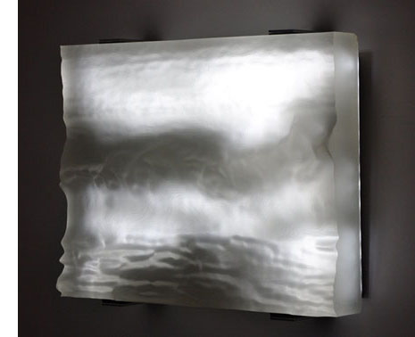
Two pieces that were highlights of Campbell’s 2014 show at Hosfelt Gallery also appear here. Again, they’re knockouts for the same reasons I cited earlier. So I quote from what I wrote in that review: “In Light Topography (Jane’s Pool), Campbell achieves an almost preternatural level of clarity by mounting single LEDs on the tips of variable-length dowels. Set perpendicular to the wall, they wink off and on like electronic fireflies, moving in a pointillist swarm to form a negative image of a woman swimming across deep space. Less dramatic, but no less riveting isTopography Reconstruction (Wave). It measures a scant 18 x 23 x 4 inches, and consists of a resin-cast seascape laid atop a film projection of breaking surf. It emits a dull, gray-white light whose flickering, shadowy contours come closer to re-creating the quality of the wave-watching experience than any work of art I’ve seen.” This is an exceptionally difficult task given the challenge of enacting or evoking a phenomenon that is all about motion, repetition and endless variation. Campbell, by creating a physical topography for his images of waves to play against, gives us a work of art that “does everything but emit bird cries and the briny smell of salt air.”
Topography Reconstruction (Wave), 2014, custom electronics, 1064 LEDs, carved resin, 18 1/2 x 23 3/4 x 4"

Where the exhibition falters is in Campbell’s collaborative works with Jane Rosen. Rosen makes exquisite drawings and sculptures based on animals at the ranch she occupies in San Gregorio. Her limestone, granite and glass sculptures, in particular, are exemplars of luminosity, and thus should be ideal mates for Campbell’s light-based approach. Problem is, neither artist fully exploits the opportunity. The five pedestal-mounted slabs of semi-opaque cast glass that Rosen presents carry only abstract stains and marks. Onto these Campbell projects footage of fluttering birds. It’s all very soothing and meditative, but not very engaging. One piece,Coffee Stains, hints at where this collaboration could and maybe should have gone. In it, Rosen draws a horse on a pane of glass in the majestic manner that has long been her signature. It provides much-needed context for Campbell’s bird images, as well as a fine demonstration of how, in her drawings, whether on glass or on paper, Rosen wrings remarkable (Morandi-like) luminosity from a predominately neutral color palette.

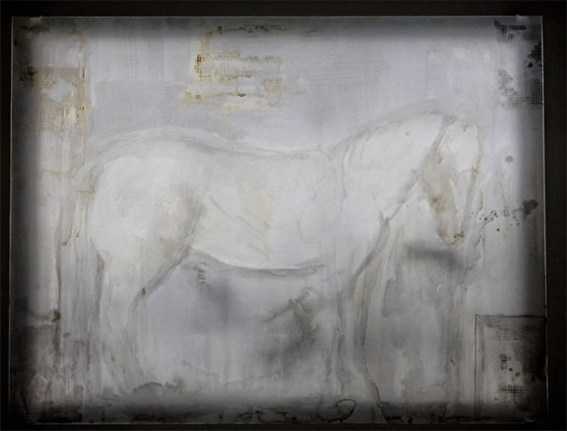
Campbell + Rosen: Coffee Stains, 2015, sumi-e ink, coffee and wash on glass panel, custom electronics and LEDs, 36 x 48"

Wildlife figures strongly in the show’s other major installation, Exploded View (Birds). Here, Campbell suspends pearl-shaped orbs from the ceiling via strands of electrical wiring. Intermittently lit, they depict birds in silhouette, looking as if they’re floating through an asteroid belt. This piece, like Light Topography (Jane’s Pool),doesn’t challenge our senses in the way Campbell’s other works do. But as an exercise in beauty, it’s unbeatable.

It’s worth nothing that Campbell began his career as an engineer; he trained at M.I.T. and holds a handful of patents for high-definition TV. As an artist he drives hard in the opposite direction, exploring the outer edges of low-resolution video. This exhibition, though it leans exclusively on the latter, seems to bridge the gap between those two poles, giving us works that, on one hand, barely cohere and on the other, works that stun with an almost hallucinatory clarity. Could it be that in technology, as in art, the alleged differences between high and low may not be as significant as we once thought? Campbell’s works stand as elegant proof that this may in fact be the case.
– DAVID M. ROTH

“Jim Campbell: New Work and Collaborations with Jane Rosen” @ San Jose Institute of Contemporary Art through February 7, 2016.

