Amy Ellingson @ San Jose Institute of Contemporary Art
Posted on 01 August 2014.

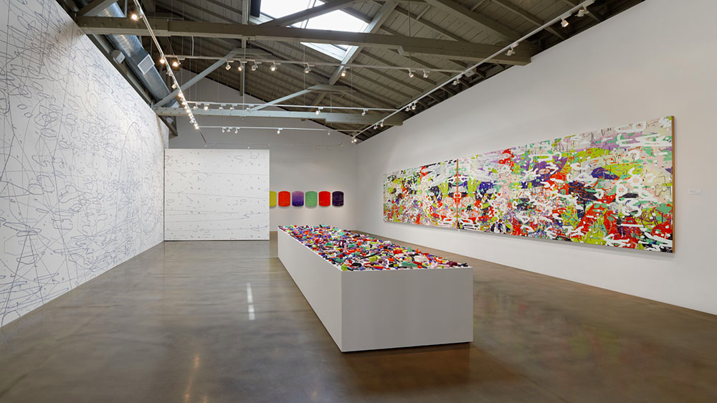
L to R: Variation: Large Delineation, 2014, site-specific mural; Variation Carta I-VI; Variation: Artifacts, 2014, 1,700 cast encaustic forms; Variation: Apparent Reflectional Symmetry Parts 1 and 2 (Diptych), 2014, oil and encaustic on 8 panels, 69 x 168 x 2". Photo: John Janca

Electronically generated forms painted in retina-tingling Pop/Op colors have long defined Amy Ellingson’s art. What’s new, and what makes her latest exhibit, Iterations and Assertions thrilling, are the ways in which the artist has reanimated and extended her catalog of recursive arcs and lines and vibratory colors. The main attraction in this show, which includes a 650-square-foot mural occupying two walls and an array of 1,700 objects cast in encaustic, is an eight-panel diptych. Created with a mix of digital and analog methods, it strikes the nervous system like an electric jolt. Unlike so-called provisional painting, which celebrates the unresolved and the untethered, Ellingson’s work links up powerfully with all the important phases of Abstract Expressionism without succumbing to any of the gimmicks that dominate so much of today's market-driven art. Her work crackles with vitality, passion and authenticity.

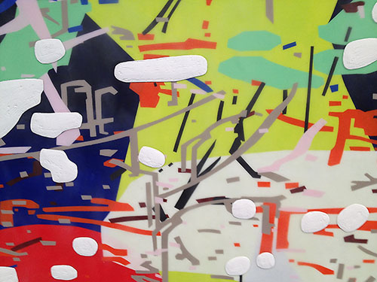
Detail: Variation: Apparent Reflectional Symmetry
You feel it the moment you lay eyes on Variation: Apparent Reflectional Symmetry Parts 1 and 2, the above-mentioned diptych. It serves as both the focal point and the source material for all the other works. In it, islands of hot color situated in layers of transparent encaustic form a fractured backdrop for a universe of torqued lines, cryptic marks, curves, branches and irregular geometries. They, too, appear at various depths and opacities. Resting on the surface, in relief, is a layer of totemic shapes rendered in pigmented wax, all white. The effect is of digital graffiti: hermetic and hieroglyphic, human and not human, referential, but only barely. As Ellingson explained in a recent conversation with the artist Maritza Ruiz-Kim on her blog, ProWax Journal: “I strive for a more pure or essential abstraction. I decided to create a vernacular of rather meaningless, noisy imagery, and I try to make it into something bigger, through accretion, repetition, accumulation, processes, materiality and scale. Through time and labor.” That labor, because of how it’s divided between the electronic warping of computer-generated lines and hand painting, yields a hybrid that truly encapsulates the art-historical moment. Where much of the modernist canon influencing Ellingson aimed for a totalizing effect, her art does the opposite. It atomizes the source material, so that when you look deeply you find yourself lost, grasping for footholds among the shapes, shards and out-of-focus forms that litter the panels of Variation: Apparent Reflectional Symmetry Parts 1 and 2. If there’s a better representation of the destabilizing, disorienting impact of the data bombardment we undergo daily I have yet to see it. Whether Ellingson, at the outset of her investigations, set out to do this I can't say; but the iterative, generative process she invented, which seems infinitely extensible, has certainly had that effect.

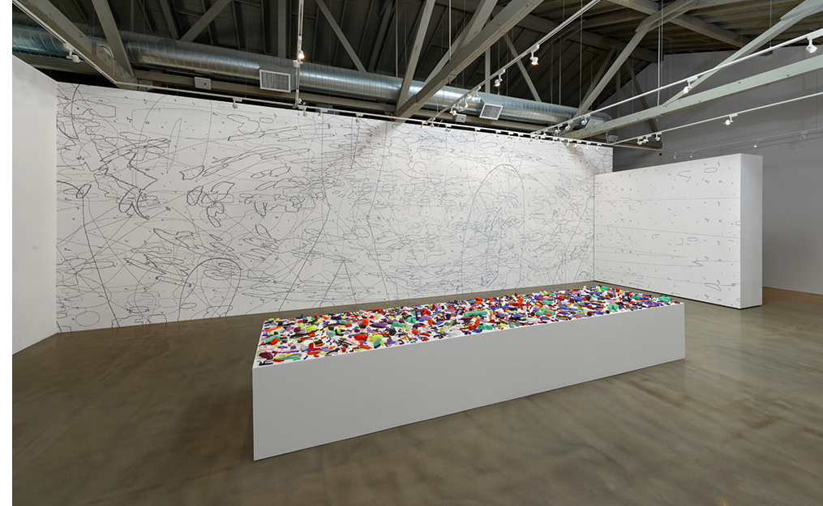
Installation View: mural and artifacts. Photo: John Janca

Variation: Large Delineation, the giant mural, opens another window into this process. Here, she’s sampled the library of forms that populate the diptych and enlarged them to monumental scale, painting them by hand onto two walls in a dull, blue-gray acrylic. Those on the largest (13 x 41-foot) wall form a loopy topographic map; the others, on a smaller (10 x 12-foot) wall, call to mind an ancient language composed of raw pixels, shredded in the manner ‘80s raster graphics. In between the diptych and the mural, Ellingson’s installed a long table filled with small wax-cast objects that read as useless tools – an attempt to concretize, in three dimensions, the objects and volumes of the diptych in the same six colors: yellow-ochre, orange, red, purple and black. The exhibit also includes a suite of shaped panel paintings that employ these same artifacts. Set against grounds of those same colors, they feel like mild fever dreams.
Mural detail

If you think of digital art as a soul-sucking realm of cold calculation destined to chip away at our humanity, Amy Ellingson will force you to recalibrate your thinking. She shows the man-machine link to be an extension of bodily instincts and neural impulses: realizations of a quest to develop forms that, she says, in her conversation with Ruiz-Kim, "confront “the enormity of contemporary virtual experience” while asserting “the humanness of painting.” The results are dazzling to behold.

-DAVID M. ROTH

Amy Ellingson: “Iterations & Assertions” @ San Jose Institute of Contemporary Art through September 13, 2014.
Squarecylinder thanks Maritza Ruiz-Kim for sharing excerpts from her interview with the artist.

