Volunteers for the Tag Project
The Tag Project has taken on a life of its own, turning into an adventure borne out of art, community, volunteerism, activism, advocacy, and education. I have never worked on a “community project” before and what made this project so special for me is that this project BECAME a community project on its own. It evolved, grew, and was nurtured by many.
When we first started, it was mostly a few friends and students helping me out with 25 tags. Then at family gatherings, we’d all be sitting around the dining table, stamping, writing and numbering tags. Soon I was shipping out kits to volunteers all across the country, to people I had never met before! Then The Tag Project was invited by various organizations, such as college groups, high school classes, churches, temples, and art organizations to host events where volunteers would come and work on the tags. My two year goal was met but not without the help of all of these people and organizations. You may note that when I speak of The Tag Project, I always speak in terms of “we”, or “us”, or “ours”. The Tag Project belongs to all the fabulous volunteers and supporters.

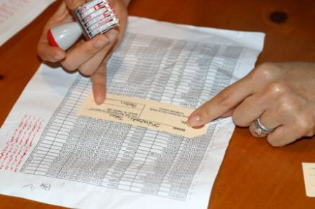
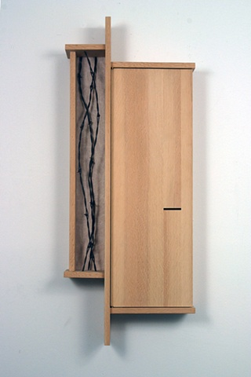
Poston, 2008, douglas fir, barbed wire, paper, tar paper

The Poston War Relocation Center, located in Yuma County (now in La Paz County) of Arizona, was the largest of the ten American concentration camps operated by the War Relocation Authority during World War II.
Poston was built on the Colorado River Indian Reservation, over the objections of the Tribal Council, who refused to be a part of doing to others what had been done to their tribe. However, officials of the Bureau of Indian Affairs overrode the Council, seeing the opportunity to bring in improvements and develop agricultural land on the War Department budget and with thousands of "volunteers," which would remain after the war and aid the Reservation's permanent population.
A single fence surrounded all three camps, though Poston II and III did not have gatehouses. The thousands of internees and staff passed through the barbed-wire perimeter at Poston I, which was where the main administration center was located.
Poston was a subject of a sociological research by Alexander H. Leighton, published in his 1945 book, The Governing of Men. As Time Magazine wrote, "After fifteen months at Arizona's vast Poston Relocation Center as a social analyst, Commander Leighton concluded that many an American simply fails to remember that U.S. Japanese are human beings."

