Best of 2015
Posted on 02 January 2016
David Roth

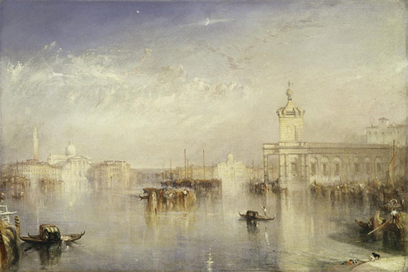
J.M.W. Turner, The Dogano, San Giorgio, Citella, from the Steps of the Europa

J.M.W. Turner @ de Young
“Possibly the best painting exhibition seen in northern California for more than a decade,” wrote Mark Van Proyen. Featuring works from the last 15 years of the artist’s life (1775 to 1851), including some of the greatest watercolors ever made, this show “captures the precise hinge moment where the radical subjectivity of Romanticism pivots to a new place, where artists dedicated themselves to exploring the tangible relationship between experience and the materials that would allow them to capture those experiences.”
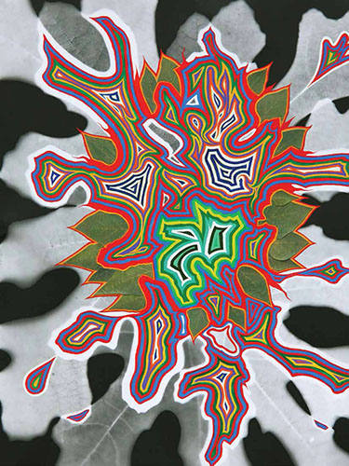
Fred Tomaselli from CJM's "Night Begins the Day"

Night Begins the Day @ CJM
The inaugural offering by the CJM’s Chief Curator Renny Pritikin and Associate Curator Lily Siegel engaged viewers by asking them to consider inconceivable immensities of the universe. “Thiswunderkammer of images, objects and moving pictures, wrote Maria Porges, “offers viewers an opportunity to meditate upon the sometimes terrifying immensity of the universe—and to wander through a modern-day experience of the sublime.” She called the show “spectacular, dreamy and enchanting.”

Robert Hudson @ Brian Gross
At the dawn of the space age, when the superpowers were vying for celestial one-upmanship, we were told that the satellites and rockets being launched would someday fall back to Earth as “space junk.” Hudson, a leading exemplar of second-generation Funk, appears to have been a beneficiary of such thinking, having built for the past 50 years, sculpture that looks like the product of an explosion in a junkyard. His sculptures may look chaotic, but close inspection reveals them to have an almost classical sense of balance, blending cosmic aspirations with the more recondite musings of an earthling — one who has few peers.

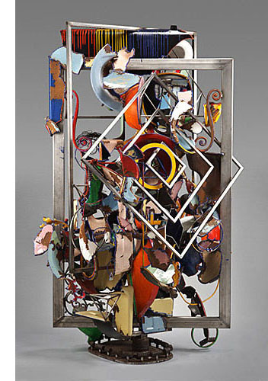
Robert Hudson, Frame of Mind
Marie Thibeault @ George Lawson
With torqued, tilted, stacked and gridded elements, Thibeault invests charged abstract paintings with a sense of entangled time,” said Julia Couzens. “She does it with crisply defined wedges painted in
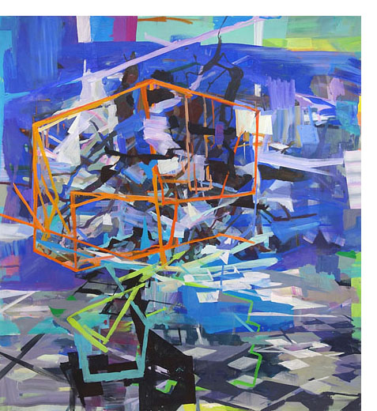
saturated colors, large geometric and free-form shapes, and teetering hand-built webs that make for dense layers of space. These constructions reference urban development, airport terminals, maps, architectural scaffolding and system collapse. The seven paintings on view took us to the brink via upended tectonic plates through which we can see the tenuous remains of houses and buildings — contingent forms that barely keep chaos at bay.”
Marie Thibeault, Night Tree

Secondhand @ Pier 24
In 2010, Google calculated that every two days we create as much information as humanity did from the dawn of civilization through 2003. Secondhand, one the most ambitious photo shows ever mounted, attempted to make sense of that dilemma as it pertains to the accumulated residue of the 150 years of photography and, more recently, glut of images being uploaded to social media each day. No exhibition could possibly make sense of it, and this one didn’t. But it definitely outlined the dimensions of the challenge, bringing together reportage, vernacular images, found photos, scientific documentation and highly eccentric examples of fine art photography by the likes of Maurizio Anzeri, Daniel Gordon, Matt Lipps and others. A head-spinning, exhausting exhibition that will not soon be equaled, due to the sheer amount of imagery surveyed and the vast amount of space required to display it all.

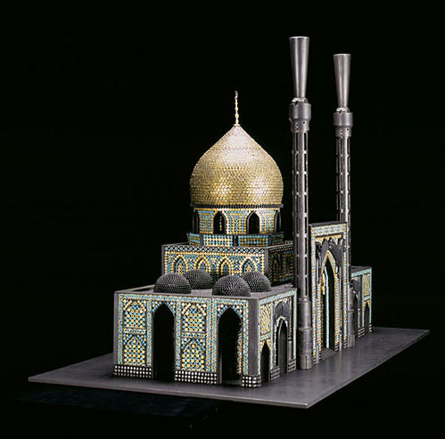
Al Farrow, Bombed Mosque
Al Farrow @ Crocker Art Museum
Farrow uses bullets, shell casings, projectiles and disassembled firearms to replicate sacred architecture. These feats of design and engineering mimicked the structural details of architecture so faithfully that even if you entered knowing full well what to expect, you couldn’t help but be shocked by the ease with which the aesthetics of weaponry translated to religious architecture. Whether, with this body of work, Farrow was pounding swords into ploughshares or merely throwing fuel on an already raging fire was hard to tell. He may well have been doing a bit of both.

Phillip Maisel @ Gregory Lind
With a combination of sculptural assemblages and photographs of similar assemblages made in the studio, Maisel has carved out a unique space for himself,” wrote Elwyn Palmerton. “His work consists of photographs of pieces of colored or mirrored plexiglass, wood and other materials propped up against a studio wall. The results tend to fall somewhere between setup photography and geometric abstraction, but several characteristics — frequent use of mirrors, a careful formalization of the arrangements and modifications to the surfaces of the prints themselves — force us to engage with his work by mentally translating the fragmented pieces back into what they once were, retracing the process by which they were composed in the studio.” (See photo below.)

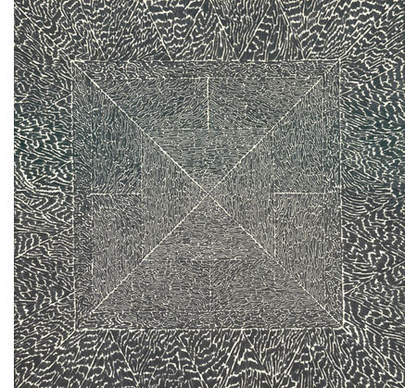
Bruce Conner, #126, 1970-71, offset lithograph on paper, 15 x 14.5"
Bruce Conner @ ICA
A conceptualist before the term was coined and an irrepressible shape-shifter whose career flipped restlessly between media, Conner (1933-2008) was one of the most incisive artists to have emerged from the Bay Area. This show which focused primarily on his paper works — the felt-tip pen mandala drawings (1963 to 1971); the collages made from 19th century magazine engravings; the inkblot pictures; as well as choice examples of his conceptual works — formed a tantalizing snapshot of the artist’s multifaceted career, soon to be the subject of a full-scale retrospective at SFMOMA when it reopens this spring.

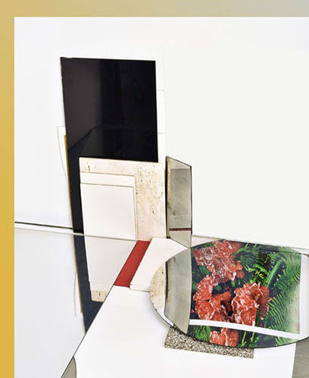
Phillip Maisel, Feldspar 1101 @ Gregory Lind
Cornelia Schulz @ Spun Smoke
A fearless practitioner of unbridled abstraction with a career dating to the 1960s, Shultz continued to amaze by teasing paint into the most improbable contortions. The frothy surfaces of her sculptural paintings brought to mind volcanic landscapes and disparate geological epochs — randomly sampled and fluidly conjoined. The paint had the texture of pulled taffy, and it ran in gullies, rivulets and curlicues, coalescing in folded slabs that had been smeared, raked, and thumb-quashed. Schulz’s retro modernist idea is that paint is a vital, life-affirming force, and that the deft manipulation of it can be a worthy end unto itself. She went at it full-throttle.

Anglim Memorial Exhibition @ Paule Anglim
Retrospective, the memorial tribute to Paule Anglim (1923-2015), was one delirious jumble of a show. Hung salon-style and packed with 115 objects representing a substantial number of the artists she represented, it could easily form the template for a museum-length survey, should some enterprising curator rise to the task. If so, beware: Anglim’s tastes ran all over the map. Her choices were guided by instinct, not salability, and she backed those commitments with an uncommon loyalty. Which is why this show — a sampling of her massively influential 50-year career that ended on April 2, 2015 with her death — was essential viewing for anyone interested in Bay Area art from 1945 to the present.

Object and the Void @ Bedford Gallery
Richard’s Serra’s observation – that “object and the void become one and the same” in steel sculpture – seems, at this remove, to be a self-evident truth: true for Serra, but not universally so. That would make it a slender peg on which to hang a show. But surprise: The Object & the Void, an exhibition of metal sculpture organized by Carrie Lederer, the Bedford Gallery’s curator of exhibitions, proved the artist’s premise to be

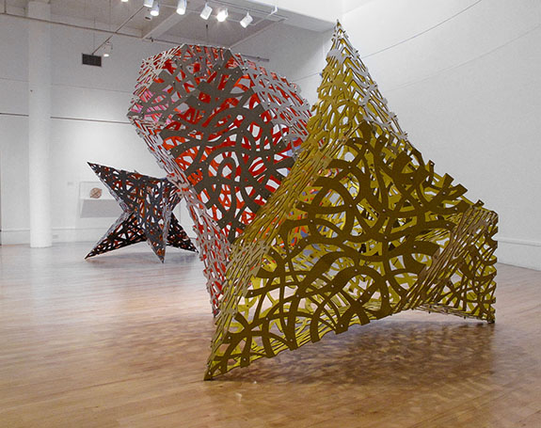
Linda Fleming, Planetesimal and Sparks at Bedford Gallery's "Object and the Void"

sturdy and extensible in ways Serra may not have envisioned when he made that remark in 2001 to Charlie Rose. The show featured Linda Fleming, Bella Feldman, Yoshimoto Saito and Clay Jensen, masters whose works transformed the Bedford’s light-filled rotunda into a catalog of the ways that metal can be cut, cast and reconfigured to challenge conventional notions of form and space.

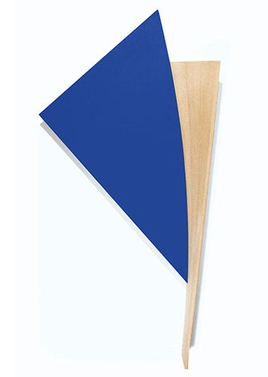
Tony DeLap, Bluey-bluey
Tony DeLap @ Rena Bransten Projects
If you failed at first glance to grasp the full impact Tony DeLap’s art, the problem wasn’t with your eyes. It was with the human brain’s instinct to deny what the eyes take in. Magicians have long exploited this gap, and so does DeLap, a semi-professional magician and one-time architectural designer whose paintings and sculptures have, for more than 50 years, famously employed visual sleights of hand. Eighty-eight years of age and going strong, he’s
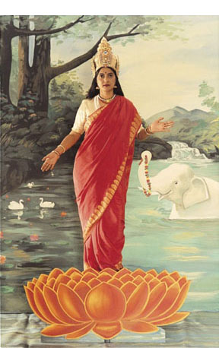
Pushpamala N. and Clare Arni, The Native Types
long been an icon within the overlapping realms of West Coast Minimalism and the Light and Space movement. This tidy but powerful show demonstrated the myriad methods by which DeLap successfully minds — and mines — the gap between reality and perception.

Postdate: Photography and Inherited History in India @ San Jose Museum of Art

There was a time not too long ago when photographers actually made pictures. Many still do. But as a spate of recent museum exhibitions suggest, photography is fast becoming the province of aggregators: artist/curators far more interested in making sense of the trillions of images already out there than with adding to the torrent of photos coming at us from television, the Internet and social media. That was the impulse behind a lot of what appeared inPostdate, a show in which ten artists of Indian heritage re-presented that country’s photographic history to assert their view of what it means. Not surprisingly, colonialist viewpoints take a pounding.

Tom Monteith @ Sac State Library Gallery
We didn’t review this museum-worthy show, but we definitely should have. SC Contributing Writer Julia Couzens, in a catalog essay, had this to say about Monteith's synthesis of American landscape traditions: “Lean planks of scraped pigment uproot severed Bunyunesque tableaus. Compressed fragments of landscape collide in sour cubist grids. Dark, hermetic slippages graft anxious, improvisational space with new topographies of doubt…becoming provisional encampments, honoring fathers and ancestors: Thomas Hill, Arthur Dove, Phillip Guston, and Charles Garabedian.” Learn more about Tom Monteith.

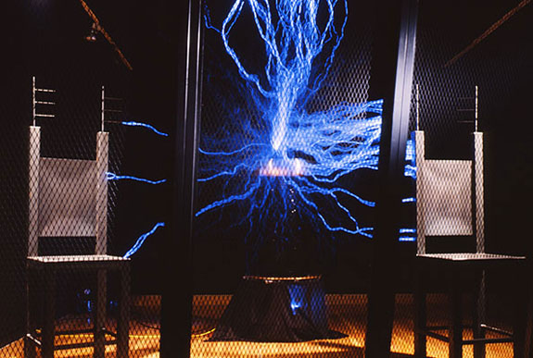
Doug Hall, TheTerrible Uncertainty of the Thing Described, 1987
Doug Hall @ SFAI
The Terrible Uncertainty of the Thing Described, Hall’s installation of video, metal and electronics, was originally acquired in 1989 by SFMOMA, but hadn’t been seen since the museum vacated the Veterans Memorial Building that same year. “Its appearance, as part of SFMOMA’s “On the Go” program, wrote Mikko Lautamo, “signaled a welcome reprise for an iconic installation” whose most notable feature is a “tesla coil that generates huge voltages of electricity which arc like lightning bolts into the air…swirling wildly and lighting the dark gallery.” Like the art film Koyaanisqatsi, which uses time lapsed footage of cities, industry, people and landscapes to describe the antipathy between modern technology and nature, Hall’s piece, Lautamo continued, forced viewers to confront “the terrible power of technology, a power usually hidden behind domestic use and a TV-friendly veneer.”

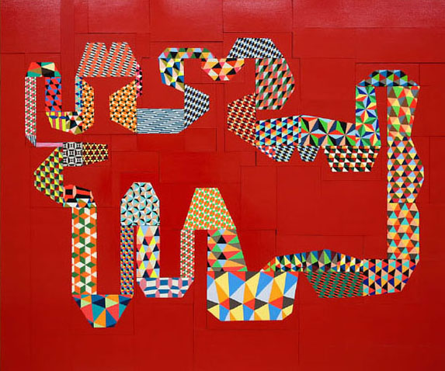
Barry McGee Untitled, paint on panel, 23 elements, 105 1/2 x 124"
Barry McGee @ Ratio 3
In his most recent show, China Boo, the artist moved in two directions at once. One part affirmed his blue-chip status with design-y paintings larded with his now-familiar loser-guy iconography; the other showcased his street-art roots with a thrift store/salon-style gallery of art made by friends, “accessed through a low opening in a wall and suggestive of a trip down Wonderland’s rabbit hole,” observed Maria Porges. The first spoke of market cachet in the language of Op-ish design; the second of “the artist’s adamant membership in a broad community of surfers/skaters,” the end result being a solo show embedded in a group show, each brilliantly conceived and displayed.

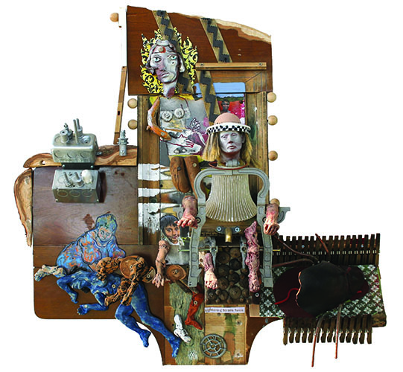
David Olivant, Lightening Strikes Twice

David Olivant @ CSU Stanislaus
Olivant’s strange and captivating assemblages, depicting people trapped in existential dilemmas, “embrace the surrealist tradition of the object trove poetique, and a wildly elaborated Rube Goldbergian zaniness that harks back to the older work of Joseph Cornell,” observed Mark Van Proyen. They display “a balance of charm, pathos and absurdity” using “figurative fragments to slyly suggest how each is a function of the other. This balance,” Van Proyen continued, “is as much a function of form as it is of what is normally called either content or signification…one that stage manages relations between multiple modes of particularity seeking salvation from a runaway complexity that is nothing if not indifferent to human folly.”

Mildred Howard @ Richmond Art Center
“Howard,” wrote Jeff Kelley, “is trying to hold something together in her works, some moments of recognition, perhaps, when keepsakes become art; when vernacular speech becomes titular and punny; when the given histories of found objects cede to the emergent content of the artist’s process; when family storytelling combusts into modernist black magic; when incongruous juxtapositions of objects and media become easy exchanges of history and memory; when an artwork asserts its aesthetic privilege while remaining open to worldly influence. Howard has been waiting alertly for decades for the objects in the studio to tell her what to do. She recognizes their metaphoric potential in relation to each other, the way words and images add up to a story. Then she ‘tells’ them.”

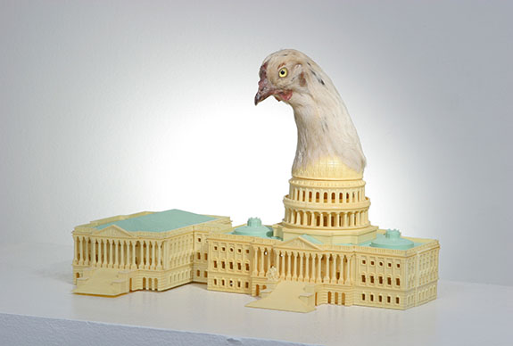
Mildred Howard, What Came First, 2007, plastic building, chicken head 11 x 16 x 9 1/2”

Garble @ Catharine Clark
When conceptual art first reached a mass audience in the late ‘60s, it shocked by asserting that standalone text could be visual art. Today, text is ingrained in so many types of art (video, installation, drawing, sculpture, painting and photography) that it doesn’t elicit so much as a raised eyebrow. Garble, a text-heavy show featuring seven gallery artists doesn’t challenge that state of affairs. Instead, by offering a kind of core sampling of current practices, it affirms a key principle of Conceptualism: that ideas, not their delivery systems, are what matter. As for garble itself, there was little; the artists delivered messages that for the most part were quite clear. But if, by using the word garble, the show sought to demonstrate how artists mess with codes of visual and linguistic communication, well, there’s was plenty of that going on in the work of Anthony Discenza, the duo known as Ligoranoreese, Charles Gute and Nina Katchadourian, the show’s stars.

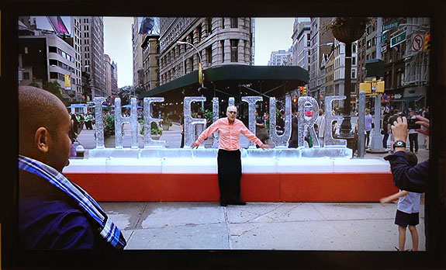
LigoranoReese, Dawn of the Anthropocene, 2014, single-channel video, 4:22

Andrew Schoultz @ Hosfelt
Schoultz’s paintings, drawings, sculptures and installations eerily affirm the pervasive sense that everything is broken. Crumbling buildings, flying debris, sinking ships, shredded currency, turban-clad soldiers and U.S. flags populate Blown to Bits. It’s political art that succeeds without didacticism, a rare thing. Schoultz not only sidesteps that pitfall, he brings dazzling draftsmanship and imagination to the task of symbolically representing the maelstrom of current events in bold, wall-sized works and installations that activate the eye as much as their immediate environs.

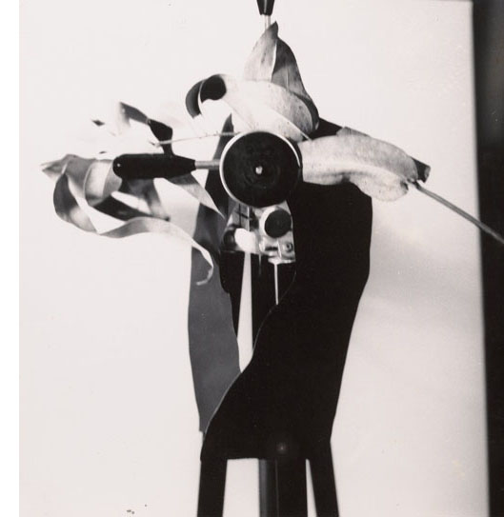
Jay DeFeo, Untitled, 1976, gelatin silver print, 8 7/16 x 8"
Jay DeFeo @ Hosfelt
DeFeo’s combination of manual and photomechanical methods marked both a connecting point to the early history of abstract photography (László Moholy-Nagy, Man Ray) and a turning away from the emotive, psychologically freighted realm of Abstract Expressionism, which dominated DeFeo’s formative years and brought her lasting fame in the form of one truly epic painting: The Rose. Alter Ego, a stunning show of DeFeo’s photos and photo-derived works, picked up at the start of that journey. It began in the early 1970s and followed DeFeo to the end of her life, which ended in 1989 at age 60. The third such show mounted by the gallery since 2011, it illuminated the fluid relationship she maintained between different media. That relationship was fueled by a continuous, syncretic tug-o-war between representation and abstraction. Fifty-five examples were view, 49 of which had never been seen publicly.

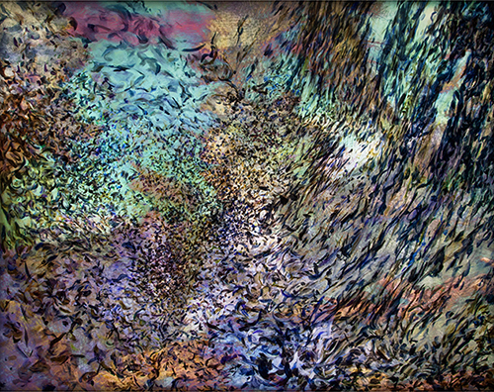
Naomi Kremer, Walkabout
Naomie Kremer @ ICA
It’s difficult to think of an artist who’s done more to make painting cinematic than Naomi Kremer. She does it by projecting moving video images onto abstract paintings to create a variety of compelling the illusions: of trees ruffled by a gentle breeze; of clouds moving across the sky as seen from the bottom of a reef; and of rays of sunlight casting shadows across sea plants swayed by the tides. These hybrids, as she calls them, demonstrate how observation changes the nature of the thing observed and, how, in so doing, they play with our sense of time. First, by integrating the pieces so tightly that it becomes impossible to distinguish the painted parts from the projected parts, and second, by presenting them as objects: an act we intuitively take to mean freezing a discrete moment. To
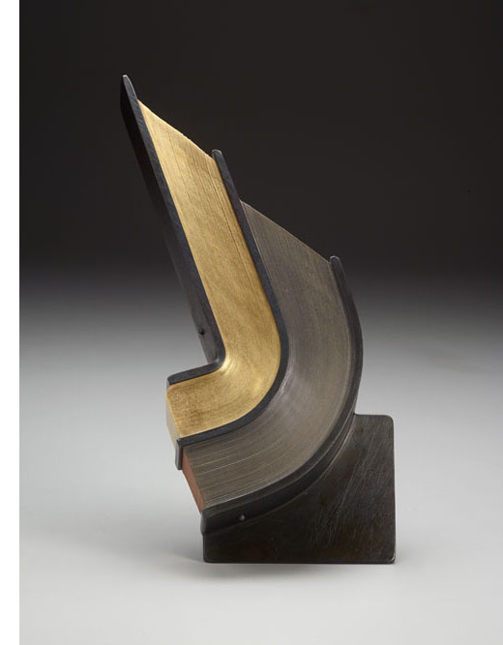
Andrew Hayes, Sufflate
look, then, is to experience that compact being broken and to entertain the idea that a painting might be a living, animate thing.

Andrew Hayes @ Seager Gray
Some of the smartest, most engaging minimalist sculpture of the past few years comes from a 33-year-old North Carolina artist named Andrew Hayes. Fusing metallurgy and bookbinding, Hayes uses slabs of steel to compress book pages into odd shapes that, with few exceptions, skirt real-world referents, including those that once resided in the pages employed. Their absence drives us to engage with the details of artist’s process: the topographically contoured pages whose outer edges often resemble water-carved rock; the barely visible surface seams where sections of curved metal conjoin to form gentle slopes; and the accordion-like sandwiching of paper into compartments of various shapes and sizes. Austere, magisterially beautiful work.

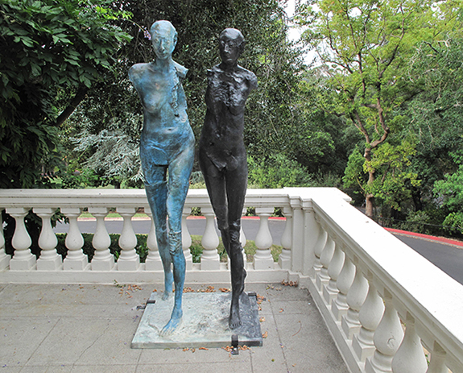
Stephen De Staebler Two Women Walking, 1992

Stephen De Staebler @ Montalvo Arts Center
With their allusions to antiquity and corroding human forms, De Staebler’s iconic sculptures powerfully activated the secluded grounds of the Villa Montalvo Arts Center, an Italianate villa and public park nestled into the base of the Santa Cruz Mountains in Saratoga,” wrote Julia Couzens. “Whether stationed on the villa’s lawns, its great veranda, or in the beckoning gardens, the settings for these five life-sized bronze sculptures were perfect.”
# # # #

