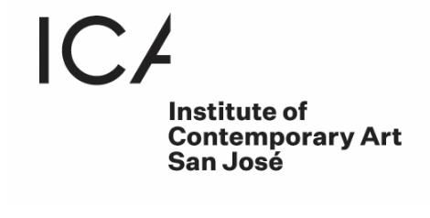
FOR IMMEDIATE RELEASE

Press Contacts:
Tachiya Bryant
tachiya@sjica.org
(669) 293-4395

San José, CA – The ICA San José is pleased to announce Blood be Water, a solo exhibition by Esteban Raheem Abdul Raheem Samayoa, a Mexican-Guatemalan artist based in Oakland, CA. Known for his profound exploration of cultural identity and personal heritage, Samayoa’s debut solo institutional exhibition opens on March 22, 2025, at the ICA San José, and runs through August 24, 2025.

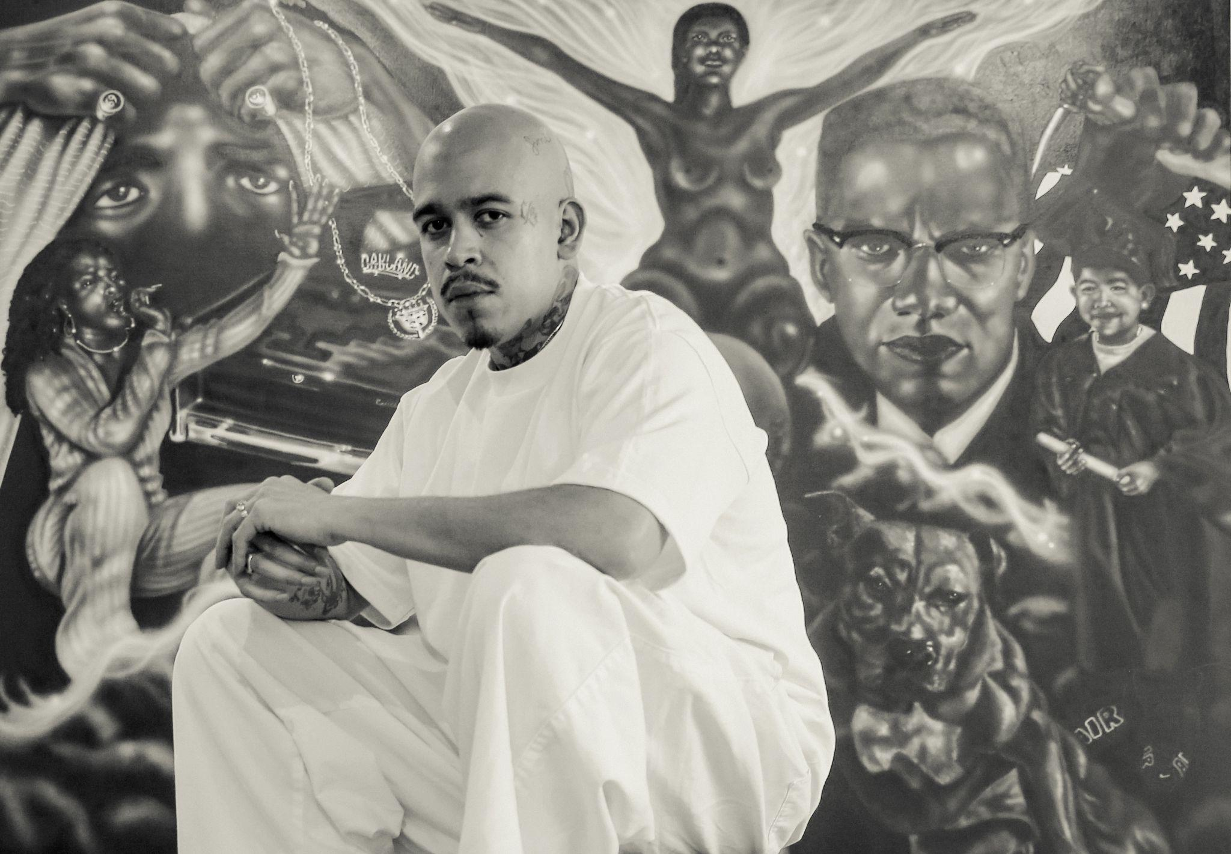
In Blood Be Water, Esteban Raheem Abdul Raheem Samayoa (2024 Artadia Bay Area Awardee) unveils a bold and immersive installation featuring a dynamic mix of airbrushed paintings, charcoal drawings, oil pastels, ceramics, and more. Drawing from the powerful traditions of muralism, street art, Latin American modernism, and folk art, his work becomes a striking and intimate journey through themes of ancestry, transformation, and the fluidity of identity. Curated by Zoë Latzer, Curator and Director of Public Programs at the ICA San José, this extraordinary showcase opens on March 22, 2025 at the ICA San José, in downtown San José, and runs through August 24, 2025.
Esteban Samayoa in his studio. (Photo by Cinque Mubarak @qlick22)

“Blood Be Water is a gift to San José,” says ICA Executive Director James Leventhal. “Our city has always been a vibrant mosaic of immigrant communities. From the farm workers who shaped the region’s past to the tech workers who now define its future, this exhibition celebrates the resilience and transformation of our diverse populations. Samayoa’s story resonates with so many of the communities we serve, and this exhibition speaks to both the weight and the beauty of those experiences.”

The exhibition’s title—Blood Be Water—reframes the old adage “blood is thicker than water,” shifting focus from biological ties to the power of chosen relationships and communal bonds. Samayoa, who recently converted to Islam, reflects on how identity is shaped by both lineage and lived experience. As he puts it, “I’m not three different things, but all of them. So it’s pretty limitless.” This concept of transformation is at the heart of his work, inspired by the biblical notion of turning water into wine—a metaphor for how individuals can redefine themselves in the face of inherited circumstances.
Through his art, Samayoa creates a space of resilience—a place where personal and collective histories meet, inviting viewers to reflect on their own stories of belonging, change, and connection. His monochromatic airbrushed paintings and charcoal drawings evoke memory and ancestral ties, while his ceramics and mixed-media works ground the exhibition in physicality and tradition. Together, these pieces forge an immersive environment that encourages communal dialogue and introspection.
Samayoa’s work has attracted the attention of global brands like Carhartt WIP, Salomon, and Cadillac, where he serves as an influential creative. His personal journey—from his deep roots in Mexican-Guatemalan culture to his conversion to Islam—adds layers of complexity to his artistic practice, making Blood Be Water not only a visual experience but a personal testament to the power of transformation.
The opening of Blood Be Water will be celebrated with a neighborhood party at the ICA San José on March 22, 2025, featuring a DJ and reception. The first public program, part of the San José State University Tuesday Night Lectures series, will take place on March 18, 2025. Additional events, including talks, workshops, and community programs, will be announced in the coming months.
Join us for this extraordinary exhibition that celebrates identity, resilience, and the power of transformation.
Blood Be Water at the ICA San José is made possible thanks to lead sponsorship from John Green and Martin Fox, along with support from Brook Hartzell and Tad Freese, Pamela and David Hornik. Programs and exhibitions at the ICA are made possible with thanks to generous support from the City of San José’s Office of Cultural Affairs, the David and Lucile Packard Foundation, and the San Francisco Foundation; significant support from Applied Materials, the Lipman Family Foundation, and Yvonne and Mike Nevens; along with additional support from SVCreates.

About Esteban Raheem Abdul Raheem Samayoa:
Esteban Raheem Abdul Raheem Samayoa (b. 1994, Sacramento, CA) is a Mexican-Guatemalan artist based in Oakland, CA, whose practice is a profound exploration of cultural heritage, identity, and transformation. Working across charcoal, painting, ceramics, and installation, Samayoa’s work captures intimate moments of nostalgia and resilience, drawing from personal and communal histories.

His mastery of black and white charcoal drawings serves as the foundation of his practice, rendering evocative scenes that feel both deeply personal and universally resonant. Beyond monochrome, he embraces vibrant color and rich textures, incorporating materials like burlap, plaster, and soil—elements that pay homage to his Guatemalan roots and the tactile nature of memory.

Samayoa’s work extends beyond self-reflection; it is a means of forging connections. By channeling personal experiences into visual storytelling, he creates spaces for dialogue, healing, and collective understanding. His art is not just a testament to his own journey but an invitation for others to see themselves within it—a celebration of community, transformation, and the enduring power of self-expression. Samayoa’s work has garnered national recognition and has been featured in numerous group and solo exhibitions. Notable recent group exhibitions include “A Scratch in the Paint” at Good Mother Gallery in Los Angeles and “Eighteen Painters” at Andrew Kreps Gallery in New York.
Press images, and headshot available, please inquire with Tachiya Bryant tachiya@sjica.org. On Instagram and social media:
- Institute of Contemporary Art San José @icasanjose
- Esteban Raheem Abdul Raheem Samayoa @wulffvnky
- Zoë Latzer @zoelatzer
- #bloodbewater
- #icasanjose

